***Objective Questions***

1. **What is the total no. of attributes present in the data?**

**Guidelines: Count all columns in both sheets separately or combined if merged.**

**Observation: Tickets Sheet: 10 attributes**

**IT Agents Sheet: 6 attributes  
Overall Total Attributes Across Both Sheets:  
10 (Tickets) + 6 (IT Agents) = 16 attributes**

1. **Which columns have inconsistent or missing values, and what is the count of such values?**

**Guidelines: Use countblank() to check for invalid values.**

|  |
| --- |
| **Count missing values** |
| **0** |

**Observation: There are no inconsistent or missing values in the datasheet.**

1. **What is the average daily ticket volume over time?**

**Guidelines: Group tickets by creation date and compute the daily average.**

**Visualization:**

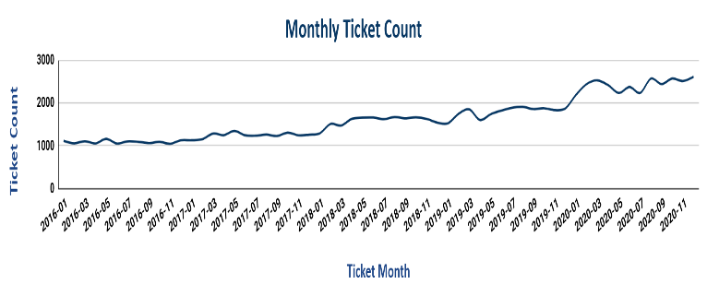

**Observation: Averaging around 54 tickets per day.**

|  |
| --- |
| **Average Daily Ticket** |
| **54.16555556** |

1. **What is the distribution of ticket categories (e.g., Login Access, System, Software)?**

**Guidelines: Use value counts of the Category column.**

**Visualization:**

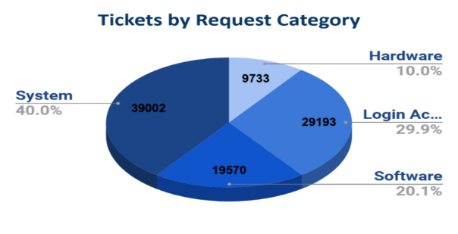

**Observation: System and Login Access are the most frequent categories, suggesting common pain points in those areas.**

1. **How many tickets has each agent handled?**

**Guidelines: Group by Agent ID and count tickets.**

**Visualization:**

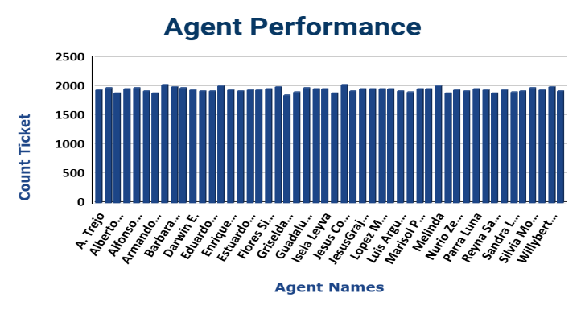

**Observation: Each agent handled average 1949 tickets.**

|  |
| --- |
| **Tickets Each Agent Handled** |
| **1949.96** |

1. **How can you extract the domain from the email addresses in the IT Agents sheet?**

**Guidelines: Split Email at @.**

**‘=RIGHT(C2,LEN(C2)-FIND("@",C2))’**

**Observation: All agents use corporate domains like fp20analytics.com, indicating potential consistency in data entry or contractor use.**

1. **How can you find the full name of an agent given their Agent ID?**

**Guidelines: Lookup Agent ID in the IT Agents sheet and return Full Name.**

**Observation: Given Agent ID: 4, the full name is Barraza Alberto. This is useful for filtering and personalizing dashboard views.**

1. **What is the count of each issue type (e.g., IT Error, IT Request)?**

**Guidelines: Group by Issue Type and count.**

**Visualization:**

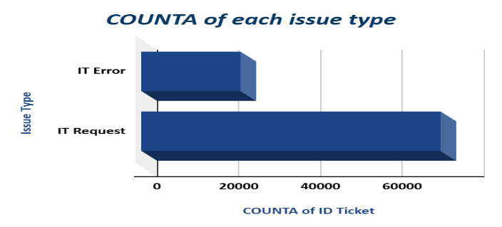

**Observation: IT Requests outnumber IT Errors by 3:1, indicating a primarily service-oriented IT support desk.**

1. **What is the daily average resolution time for tickets?**

**Guidelines: Group by date and compute mean of resolution time.**

**Visualization:**

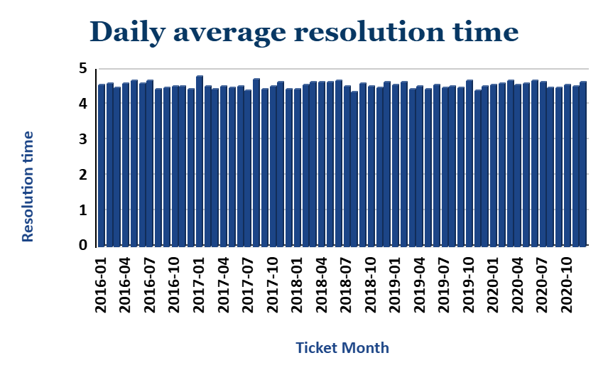

**Observation: Resolution time averaged 4.5 hours daily.**

|  |
| --- |
| **Average Resolution Time** |
| **4.549826678** |

1. **How has the volume of tickets changed over time?**

**Guidelines: Analyze trend by date – daily, weekly, or monthly.**

**Visualization:**

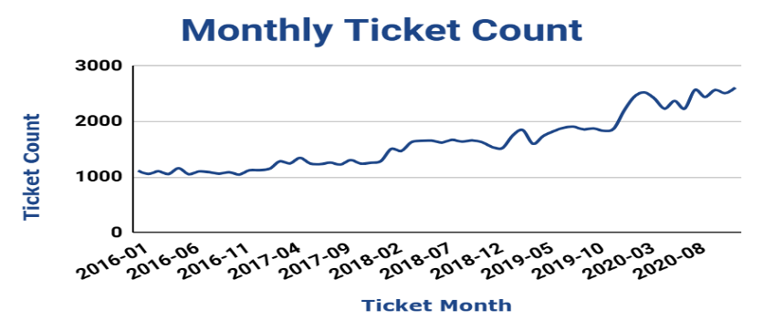

**Observation: Ticket volume grew steadily over the first quarter, suggesting increased system usage or reliability issues.**

1. **What is the average age of the IT agents?**

**Guidelines: Compute mean of the Age column in agent dataset.**

**Observation: Average age of the IT agents is 39 years.**

1. **Is there a correlation between the severity of issues and the resolution time?**

**Guidelines: Use CORREL Function for this question.**

**Visualization:**

|  |
| --- |
| **correlation between the severity of issues and the resolution time** |
| **-0.04053634915** |

**Observation: The correlation between severity of issues and resolution time is -0.0405, which is very close to zero.** **The value -0.0405 indicates a very weak negative correlation.** **This means that as severity increases, the resolution time tends to decrease slightly, but the relationship is so weak that it is likely not meaningful.**

1. **How many categorical columns are there in the data?**

**Guidelines: Count columns with data type object or with limited unique values.**

**Observation: The dataset contains 5 key categorical columns, their names are- Category, Issue Type, Severity, Priority, and Agent ID.**

**These variables are essential for filtering, segmenting, and creating interactive dashboards.**

**. These fields allow slicing data by ticket types, severity levels, and team workload.**

**Subjective Question**

1. **If there is an investment, should it be used to hire more IT agents, improve training programs, or upgrade ticket management software?**

**Analysis: Perform a cost-benefit analysis using ticket resolution and satisfaction metrics.**

**Guidelines: For hiring more IT Agents use a pivot table to analyze ticket counts per agent alongside average resolution time and satisfaction score. Evaluate workload distribution across agents by plotting ticket volume versus performance metrics.**

**Which could look like this:**

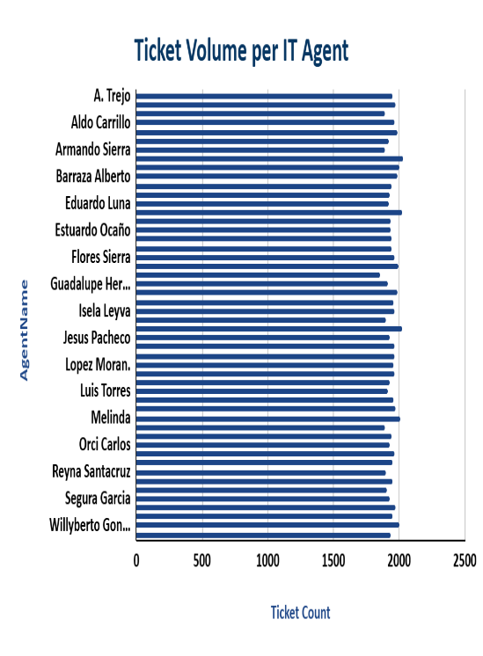 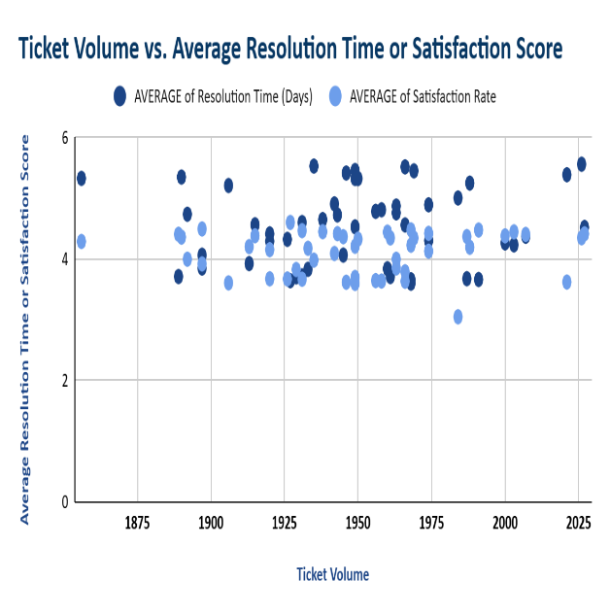

**Insights:**

* **Ticket Volume Is Similar Across Agents: Most agents have resolved around 2000 tickets, indicating balanced workload distribution.**
* **A small subset of agents handles a disproportionately high number of tickets, yet still maintain high satisfaction and fast resolution.**
* **Several agents with lower ticket volume underperform in both resolution time and satisfaction—indicating uneven workload distribution.**
* **Some agents may be overloaded, potentially risking burnout and decline in service quality over time.**

**Recommendations:**

* **Rebalance workload before hiring: redistribute tickets more evenly to assess whether existing capacity can meet demand.**
* **Consider hiring more agents if resolution times and satisfaction remain suboptimal even after training and load balancing.**
* **Factor in cost-benefit by projecting improved satisfaction and reduced resolution delays versus the cost of new hires.**
* **Implement targeted training for underperforming agents, especially on recurring high-severity or low-rated ticket types.**

**Guidelines: For improve training programs assess whether training programs improve IT agents' resolution time and satisfaction scores, compared to agents who may not have received adequate or recent training.**

**Which could look like this:**

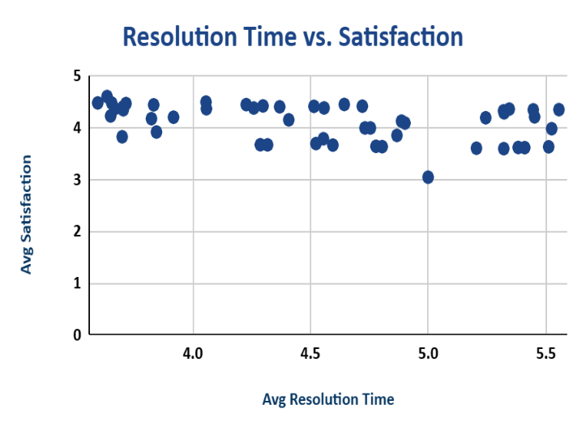 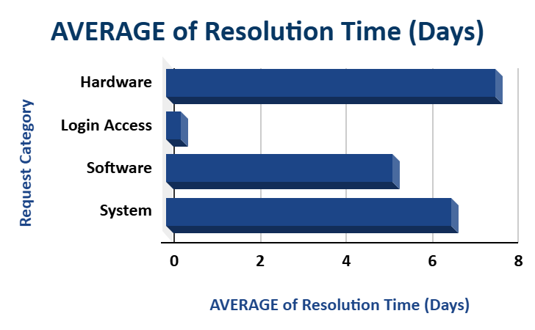

**Insights:**

* **Majority of agents maintain high satisfaction: Most agents have average satisfaction scores between 4.0 and 5.0.**
* **Satisfaction remains relatively stable across varying resolution times: Even when Avg. Resolution Time increases (up to 5.5 hours), satisfaction doesn't drop drastically for most agents.**

**Recommendations:**

* **Identify agents with satisfaction < 3.5 and resolution time > 5 hours. Provide focused coaching on Time management, technical skills for common issues, Customer communication soft skills.**
* **Build Skill-Based Training Modules and focused on: Troubleshooting efficiency, reducing unnecessary escalations, Using internal tools more effectively.**
* **Monitor Post-Training Impact: After rolling out training: Replot this chart in 1 month and 3 months, Track shift in satisfaction and resolution time, Improvement = evidence that training investment is paying off.**

**Guidelines: For upgrading ticket management software cross-analyze priority vs. severity alignment to assess whether high-priority or high-severity tickets are being resolved appropriately.**

**Which could look like this:**

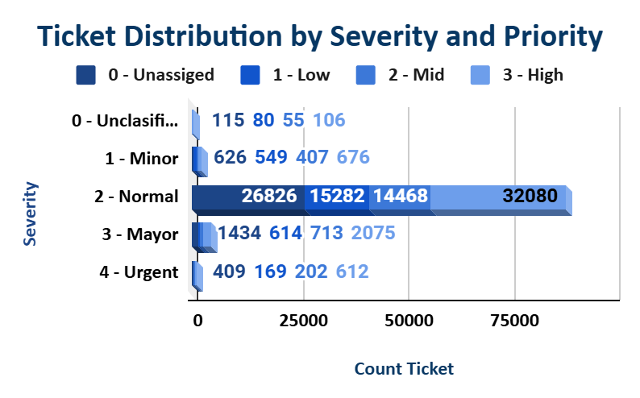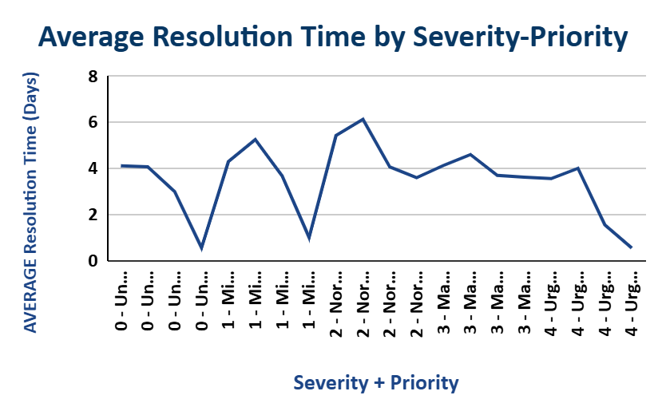

**Insights:**

* **Over 26,000 Severity 2 (Normal) tickets have Unassigned priority, and many have low or mid priority.**
* **Misaligned combinations (e.g. Normal–Low Priority) lead to longer resolution times.**
* **Well-aligned pairs (e.g. Urgent–High Priority) are resolved the quickest.**

**Recommendations:**

* **Implement Rule-Based Prioritization: Auto-assign priorities based on severity (e.g. Urgent → High).**
* **Automatically escalate tickets if high severity is combined with unresolved or low priority status beyond SLA thresholds.**
* **Display all high-severity tickets with low/unassigned priority in real-time.**
* **Measure before-and-after resolution times and satisfaction scores.**

1. **Which agents need additional training based on their performance metrics?**

**Analysis: Identify agents with the lowest satisfaction ratings and longest resolution times.**

**Guidelines: Use a pivot table to analyze agent performance. Focus on two key metrics: Average Satisfaction Score**

**Average Resolution Time**

**Which could look like this:**

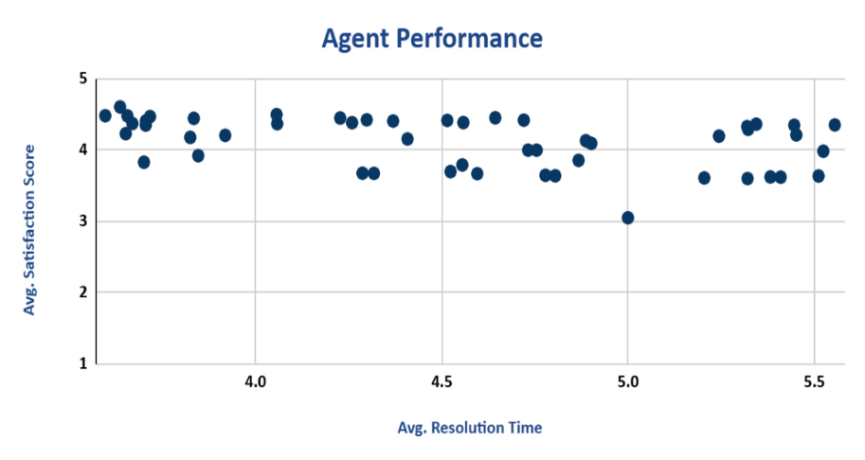

**Insights:**

* **Most agents maintain satisfaction scores above 4.**
* **Resolution times mostly fall between 3.5 to 5.5 hours.**
* **There are no agents achieving satisfaction scores below 3.0, except one outlier at 5.0 hours with ~3.0 score.**
* **Performance Outliers: Agent 39 have high average resolution times (>5.5 hours) and agent 19 have low satisfaction ratings (<3.0).**

**Recommendations:**

* **For Underperforming Agents: For those with resolution times >5.2 hrs, provide coaching on time management and ticket prioritization.** **Some agents may need support in both areas—offer personalized performance improvement plans.**
* **For High-Performing Agents: Acknowledge agents with high satisfaction and fast resolution (top-left quadrant).**
* **Trejo takes significantly longer than average to resolve tickets and receives low satisfaction. This suggests difficulty in handling workloads efficiently and possibly poor communication with end users.**
* **Alfonso has the lowest satisfaction score on the list, combined with a slow resolution time. Indicates serious concerns in both technical depth and interpersonal service quality.**
* **Lorena is one of the slowest agents, and her satisfaction ratings are also well below average. She likely struggles with both time handling and user perception.**
* **Sandra is consistently underperforming in speed and user perception. She may lack assertiveness or the ability to take control of support conversations.**
* **Jose’s resolution time is borderline acceptable, but the low satisfaction shows room for improvement in how he interacts with users and explains solutions.**

1. **Do certain categories of requests have longer resolution times?**

**Analysis: Analyze the resolution times by request category.**

**Guidelines: Use a pivot table to group tickets by Category and calculate.**

**Which could look like this:**

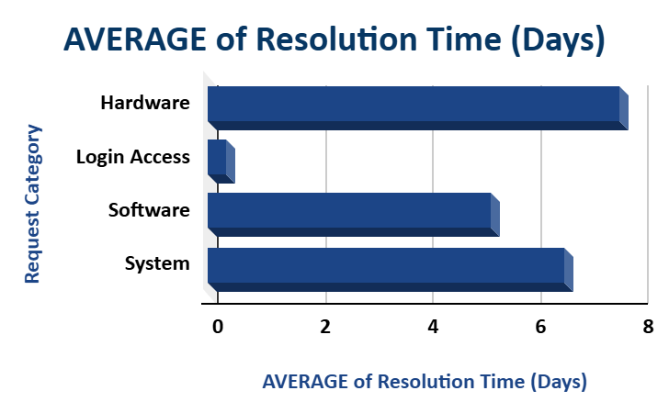

**Insights:**

* **Longest Resolution Times: Hardware (7.6 hrs) and System (6.6 hrs) requests take the longest to resolve, likely due to their complexity or interdepartmental dependencies.**
* **Shortest Resolution Times: Login Access resolved the fastest, possibly due to well-defined procedures or automation.**

**Recommendations:**

* **Process Improvement: Review workflows for Hardware and System requests. Introduce specialized handling teams or automation where possible.**
* **Specialized Training: Offer deeper technical training or troubleshooting playbooks for agents handling Hardware and System tickets.**

1. **How effective are the current software tools in managing IT tickets?**

**Guidelines: Evaluate the impact of the new software tools by comparing how effectively tickets of varying priority and severity levels are managed.**

**Which could look like this:**



**Insights:**

* **High Volume of Normal Severity Tickets: Normal severity tickets are overwhelmingly the most common, making up 90% of all tickets.**
* **Priority Assignment Issues: A substantial number of tickets (especially in Normal and Mayor) are still marked as Unassigned Priority.**

**Over 26,800 tickets in Normal severity are unassigned, which could cause bottlenecks or SLA breaches.**

* **Urgent Tickets Are Fewer but Non-negligible: Although relatively low in number, Urgent tickets still see a significant number at High Priority (612), showing that some critical issues are appropriately escalated.**

**Recommendations:**

* **Improve Priority Assignment Logic: Establish and enforce priority-setting guidelines for support staff.**
* **Enhance Automation & AI Support: Use AI-based classification to better predict ticket severity and priority based on historical resolution time, category, or impact.**
* **Implement Auto-Escalation Rules: Set rules to automatically escalate unresolved high-severity tickets (e.g. Urgent or Mayor) within a specific timeframe.**

1. **How has the performance of the IT support team changed over time (e.g., monthly, or quarterly)?**

**Analysis: Trend analysis using time series charts.**

**Guidelines: Use a time series trend analysis to evaluate changes in the following metrics over time (monthly): Average Resolution Time and Average Satisfaction Rate. Also Compare year-wise and category-wise ticket volumes to identify shifting support demands and allocate resources more effectively.**

**Which could look like this:**

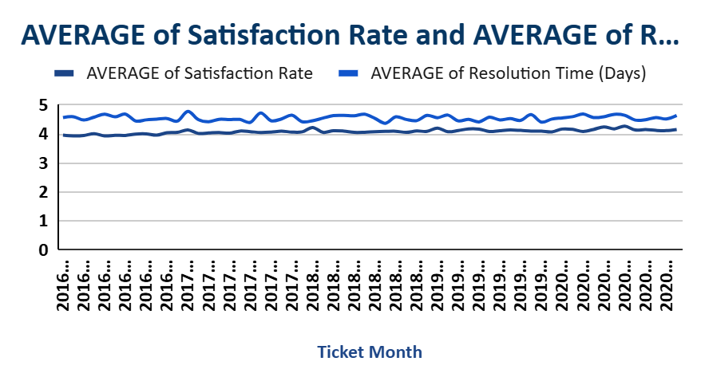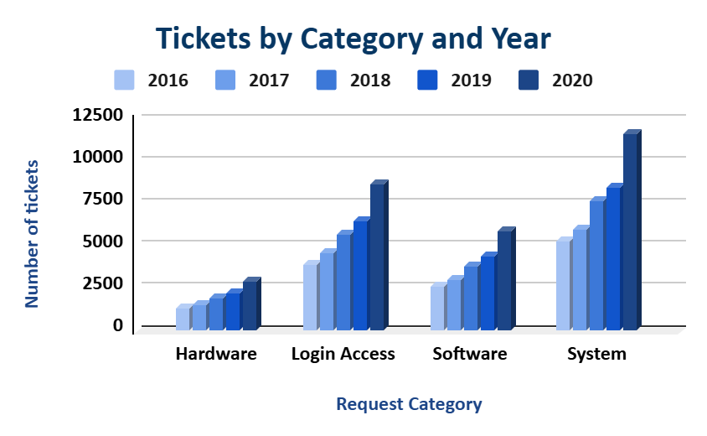

**Insights:**

* **Average of Satisfaction Rate and Resolution Time:**
* **Continuous Improvement: Average resolution time is steady over 5 months.**
* **Average Satisfaction Rate remains consistently high, around 4.0–4.5, over 5 years.**
* **Tickets by Category and Year:**
* **Overall ticket volume increased every year across all categories.**
* **System category shows the highest growth, surpassing 10,000 tickets in 2020.**
* **Login Access is consistently the second highest and shows steady growth.**
* **Hardware remains the lowest in volume but also increases steadily.**

**Recommendations:**

* **Average of Satisfaction Rate and Resolution Time:**
* **Maintain consistency: The steady performance reflects a reliable support structure — continue regular reviews to sustain quality.**
* **Monitor anomalies: Even minor dips or spikes should be investigated early.**
* **Tickets by Category and Year:**
* **System & Login Access: These two categories need more resources (dedicated teams, automation) to manage rising demand.**
* **Capacity planning: Allocate agents and training based on the rising trend, especially in System-related tickets.**

1. **If we invest more on tech (Hardware, software, etc), do you think it will improve the ticket resolution times and employee satisfaction?**

**Analysis: Use historical data to project potential improvements.**

**Guidelines: Analyze category-wise historical data to identify correlations between resolution times and employee satisfaction. Use these patterns to estimate how investing in technology could reduce resolution times and boost satisfaction**

**Which could look like this:**

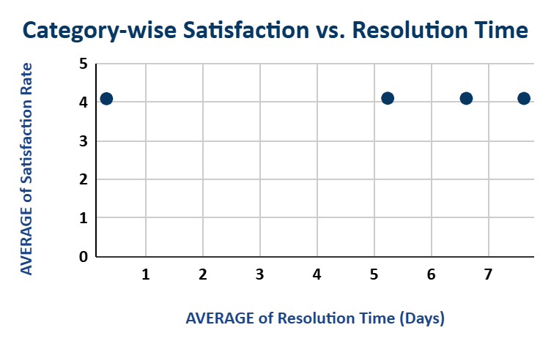

**Insights:**

* **Despite variation in resolution time (from ~1 to ~7 days), the average satisfaction rate remains around 4 for all categories.**

**This indicates no strong negative correlation between resolution time and satisfaction in this dataset.**

* **The point around 1 day resolution has slightly higher satisfaction (~4.2), suggesting that faster resolution might marginally improve satisfaction, though the difference is small.**
* **Categories with Longer Resolution Time: These still maintain satisfaction levels around 4.**

**This implies that users may tolerate longer wait times if issues are handled well, or expectations are managed.**

**Recommendations:**

* **Tech Investment Should Be Selective: Since satisfaction is not significantly dropping with longer resolution times, immediate tech investment across all categories may not be justified.**
* **Enhance Communication & Expectations: Since users seem satisfied even with 5–7 days of resolution, invest in better communication and updates during the resolution process, rather than only focusing on speed.**
* **Prioritize Based on Category Criticality: Prioritize investment in categories where delayed resolution affects productivity or business continuity, even if satisfaction is not visibly low.**

1. **What are the key performance metrics for IT agents, and how can they be improved, do we need to fire any agents?**

**Analysis: Define and analyze metrics such as average handling time, satisfaction scores, and number of tickets resolved.**

**Guidelines: Evaluate IT agent performance using core metrics such as resolution time, satisfaction scores, and ticket volume, prioritizing support, and development over termination.**

**Which could look like this:**

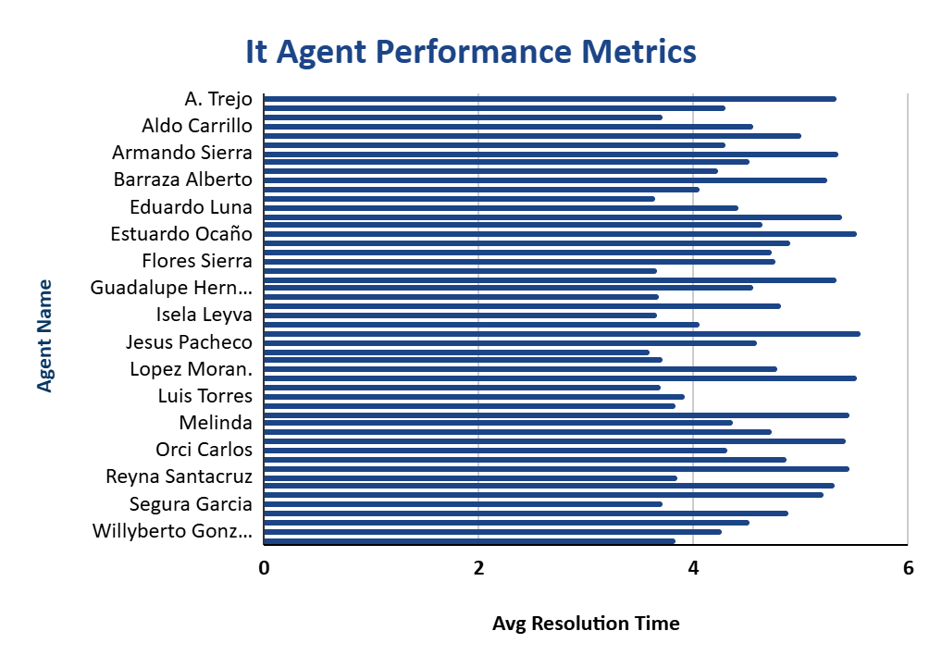

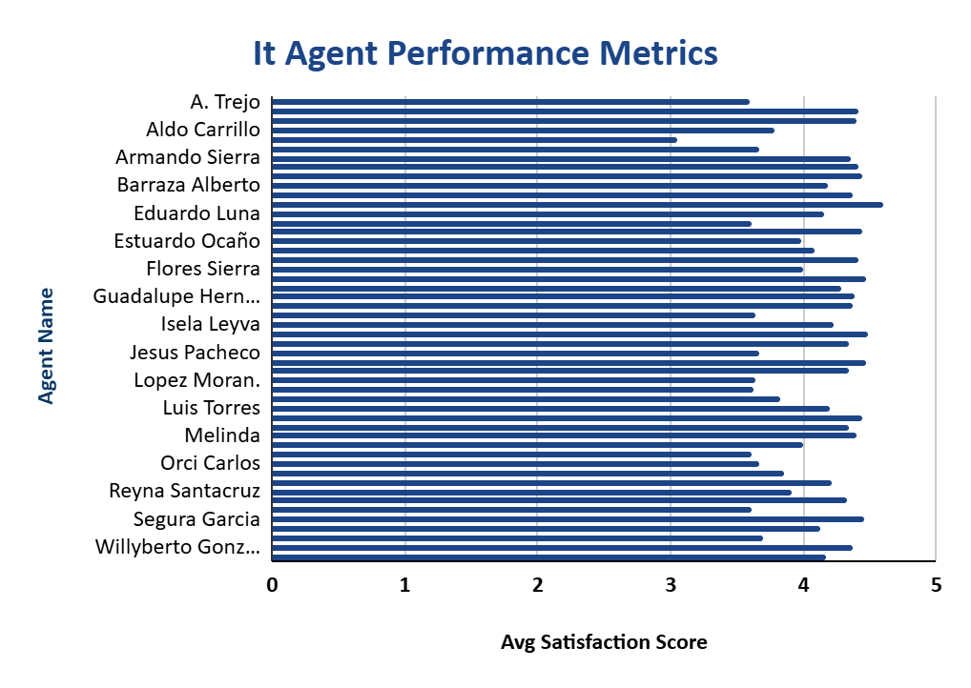

**Insights:**

* **Ticket Volume Is Similar Across Agents: Most agents have resolved around 2000 tickets, indicating balanced workload distribution.**
* **Resolution Time Varies Slightly: While differences are subtle, some agents (e.g. Eduardo Luna, Flores Sierra) show higher average resolution times, suggesting delays or more complex issues.**
* **Satisfaction Rates Are Generally High: The red bars are very short for most agents, implying consistently good satisfaction scores. However, one or two agents (e.g., Barraza Alberto, Jesus Pacheco) show relatively lower red bars.**

**Recommendations:**

* **Encourage Knowledge Sharing: Have top-performing agents mentor others. Agents with high satisfaction and low-resolution times can help improve overall team performance.**
* **Monitor Continuously: Set benchmarks and review this dashboard monthly to spot trends. Automate alerts for agents whose resolution time or satisfaction drops below a threshold.**

**Do Not Fire Anyone Based Solely on This Data: Since workload is evenly distributed and overall satisfaction is strong, focus on support and skill improvement before considering termination.**

**All agents are handling a comparable number of tickets, and most maintain high satisfaction levels. Instead of termination, use coaching, mentoring, and performance improvement plans. Only consider termination if an agent repeatedly underperforms over time *despite support* and shows no willingness to improve.**

1. **How do employee demographics (e.g., department, seniority) impact satisfaction and ticket outcomes?**

**Analysis: Segment analysis using filters and pivot tables.**

**Guidelines: Use pivot tables to compare average resolution time and satisfaction rates across employee age groups, departments, and seniority levels.**

**Which could look like this:**

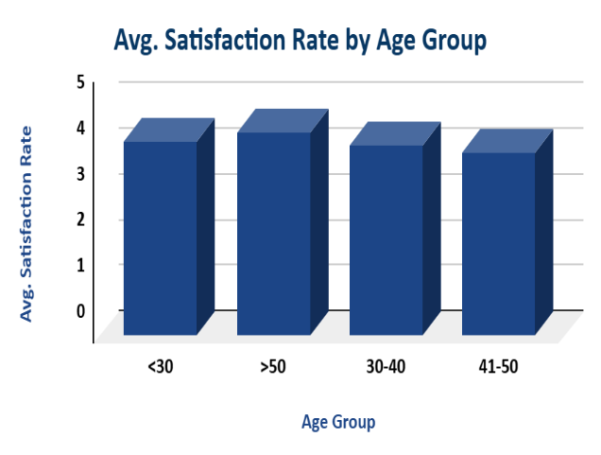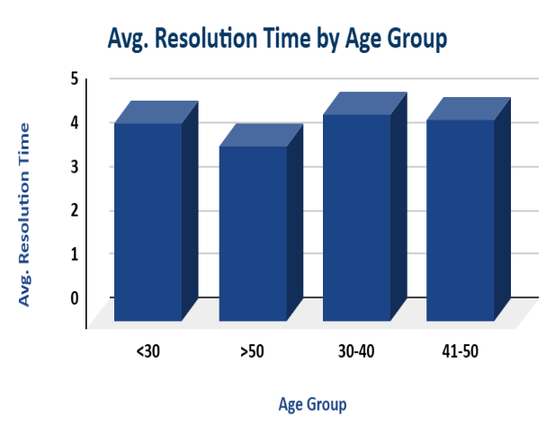

**Insights:**

* **Agents under 30: Satisfaction Rate ~4.2 and Resolution Time ~4.4 days, despite having a decent satisfaction rate, their resolution time is comparatively high.**
* **Agents aged 30–40: Satisfaction Rate ~4.1 and Resolution Time ~4.7 days (highest), This group has the highest average resolution time, which could be impacting satisfaction negatively.**
* **Agents aged 41–50: Satisfaction Rate ~3.9 (lowest) and Resolution Time ~4.6 days, this group has both the lowest satisfaction score and a high-resolution time, suggesting a performance concern.**
* **Agents over 50: Satisfaction Rate ~4.4 (highest) and Resolution Time ~3.9 days (lowest), This age group performs best overall, with high satisfaction and fast resolution times.**

**Recommendations:**

* **Targeted Training for 30–50 Age Group: Focus on improving time management and technical troubleshooting skills to reduce resolution times and increase satisfaction.**
* **Mentorship Programs: Pair older agents with agents aged 30–50 to facilitate knowledge transfer and improve performance consistency.**

1. **Identify the trends for IT support operations based on ticket volumes and satisfaction, and mention the peak and stable times?**

**Analysis: Use pivot tables and charts to identify peak and off-peak hours.**

**Guidelines: Use pivot tables to group ticket data by time dimensions (hour, weekday, or month) and analyze: Ticket Volume and Average Satisfaction Rate.**

**Which could look like this:**



**Insights:**

* **Peak Times: Peak Ticket volumes steadily increase from 2020-12, with a parallel rise in satisfaction—indicating performance is scaling well with demand.**

**Recommendations:**

* **Increase agent availability match peak demand.**
* **Encourage non-urgent internal IT requests outside peak hours where possible.**

1. **What metrics should be included in the final dashboard to provide a comprehensive view of call canter performance and guide investment decisions?**

**Guidelines: Design the dashboard to track key metrics like ticket volume, resolution time, satisfaction trends, and issue categories. Use visual breakdowns by severity, priority, and resolution time to identify performance gaps. Add interactive slicers for flexible filtering by time, agent to support data-driven investment decisions.**

**Which could look like this:**

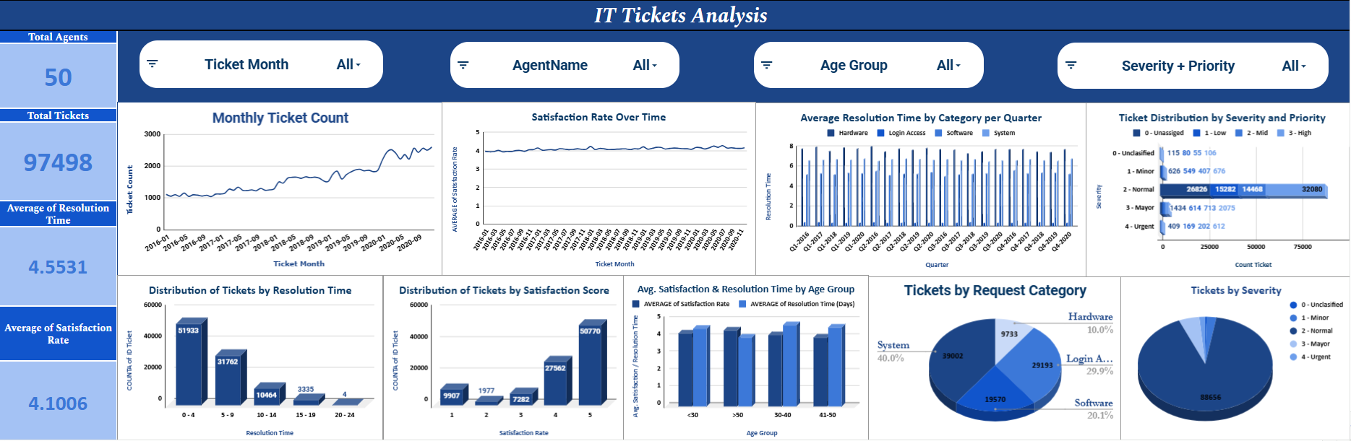

**Insights:**

* Resolution time average: ~4.55 days

May be acceptable depending on SLA, but opportunity exists to reduce it.

* Average satisfaction: ~4.1 out of 5

Slight room for improvement; investigate reasons for lower ratings

* Urgent & Minor tickets are fewer but take longer: Indicates potential strain on response capabilities for critical tickets.
* Younger and older age groups (under 30, over 50) show lower satisfaction: Might suggest communication or expectation mismatches that need addressing.
* Ticket resolution distribution shows long tail: Many tickets resolved quickly, but a chunk takes over 15 days.

**Recommendations:**

* Invest in Self-Service & Automation Tools: Build or enhance a **self-service knowledge base**, FAQs, and **AI-driven chatbot support**. Also introduce **automated password reset and system access workflows**. Its Improve resolution time and satisfaction simultaneously.
* Enhance Workforce Planning & Training: Implement **agent performance analytics tools** for real-time monitoring. Provide **targeted training** for underperforming agents. Its Improve consistency in resolution time and increase overall satisfaction.
* Implement Satisfaction Feedback Loop: Deploy **follow-up feedback mechanisms** (mini-surveys, live feedback calls). Use **sentiment analysis tools** to mine feedback for root causes. Its Identify service pain points.